Answers
Task 1
Think of a webpage or website that you often visit.
(a) Write the URL below.
Answer depends on the student. An example would be:
https://duckduckgo.com
URL: Answer depends on student choice.
(b) Write the domain name or host name below. (The domain name would be duckduckgo.com, whilst an example of a host name would be www.duckduckgo.com).
Answer depends on student choice.
(c) Make use of the ping utility to find out the IP address of the domain name.
If you have access to a command prompt or terminal window, enter the command:
ping <domainName>
Otherwise, make use of an online ping utility such as:
https://www.site24x7.com/ping-test.html
https://www.ipaddressguide.com/ping
State the IP address of the domain name you gave in (b)
Example for duckduckgo.com:
52.149.246.39
(d) Find the IP address of your computer (or the router that is connected to the Internet).
Make use of an online utility to do this such as:
https://whatismyipaddress.com/
Answer depends on the IP address of the computer or router.
(e) Complete the below diagram to explain what happens when the user requests the browser finds the URL (web address) you gave in part (a).
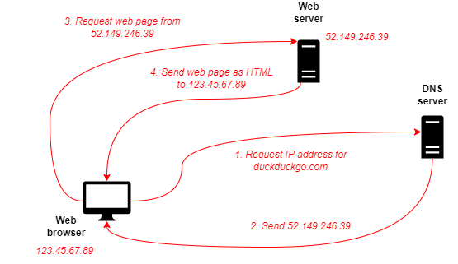
Student answers will vary depending on the IP address of their computer/school and the domain name they have chosen.
Task 2
Complete the table below by carrying out the following:
- Visit two e-commerce websites and add items to the shopping basket. Close the browser, then return to the websites to see if they still have the items to determine if they were using persistent cookies or session cookies.
- Log in to two further websites that you use. Close the browser, then return to the websites to see if they have remembered your log in. Determine if they are using persistent cookies or session cookies.
Web address | Website name | Does the website remember the items in your basket, or that you are logged in? | Does the website use persistent cookies or session cookies to do this?
Answers depend on student choice of websites. If items are lost from the shopping basket, or the user needs to log in again, the site makes use of session cookies. If the website has ‘remembered’ these details, then it makes use of persistent cookies.
Task 3
Students may have the ability to view cookies disabled. In which case you may be able to demonstrate cookies that are stored on your browser.
Visit one of the websites you gave in Task 2.
Find a list of the cookies that were sent to you.
An online help guide should be able to help you view cookies, such as:
https://www.wikihow.com/View-Cookies
Write down the names of some of the cookies and what information is stored in them.
Answers will depend on the cookies that students have stored on their computers.
Information that will be stored includes:
- Cookie name
- Value – this will sometimes just store a value that is used as an ID number. The web server may then store this ID in a database that contains more information about the user. Other cookies may store interesting data such as user settings.
- Domain name / host name
- Path
- Expiry date

